Math 8 Application 5 Name ________________________
Show all your work!

1. Circle the letter that represents the approximate location on the number line of $\sqrt{109}$.  A B C D  0 5 10 15 | 2. Simplify without a negative exponent:  7⁻² = | 3. Solve for x:  x⁵ = 32
4. Write in standard notation.  3.38 ∙ 10⁻⁵ | 5. Write the product in scientific notation.  (5.2 ∙ 10³) (3.7 ∙ 10³) = | 6. Solve for x.  10x +15 = -5x + 19
7. What type of transformation of Figure A resulted in Figure B?  A  B | 8. Find the length of side a below.  a 4 in.  3 in. | 9. Find the measure of angle b.  42°  b
10. Put the following rational numbers in order from smallest to largest.  .14, $\frac{1}{4}$, -.14, $\frac{1}{5}$ | 11. Estimate the product below.  76,210 ∙ 425 = | 12. Write the fraction as a percent. $\frac{5}{8}$
13. Fred made the following pattern with chips. Write an equation that describes Fred’s function | 14. Graph Fred’s function.  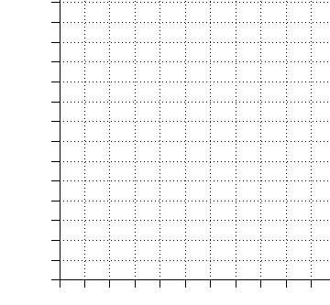 | 15. Complete the table.
   |  | o
   | o | o
  o | o o o | o o o o o
   | o | o
   |  | o
  Stage 1 | Stage 2 | Stage 3
  Stage | Total chips
  1
  2
  3
  5
  10
16. What is the sale price of a pair of $40 jeans that is marked 30% off? | 17. Find the volume of a cone with a radius of 10 mm and a height of 15 mm. | 18. Sara traveled 365 miles in 5 hours. What was her rate of speed in miles per hour?
19. Juan’s quiz scores are 45, 30, 50, 25, and 45. What is the mean of his quizzes? | 20. Fred made 4 giant 12 ounce cookies. How many total pounds of cookie is this? | Number correct  5 minutes_______  Total___________

